Guide to Exercise progression
GENERAL EXERCISE PRINCIPLES

ENDURANCE | STRENGTH | POWER
Endurance is the ability of muscles to work for a longer period of time.  Therefore lighter resistance with increased repetitions done slower are important to promote endurance.  Generally the rest time is about 30-90 seconds between sets | Strength is defined as the muscles ability to move against resistance. To improve strength a greater resistance is needed for about 8-12 repetitions with longer rest periods and in a slower controlled manner. | Power is determined by the amount of resistance muscles can move quickly. To improve power, exercise against heavy resistance in an explosive manner for a low number of repetitions and 3-6 sets. An extended rest is often needed to fully recover.
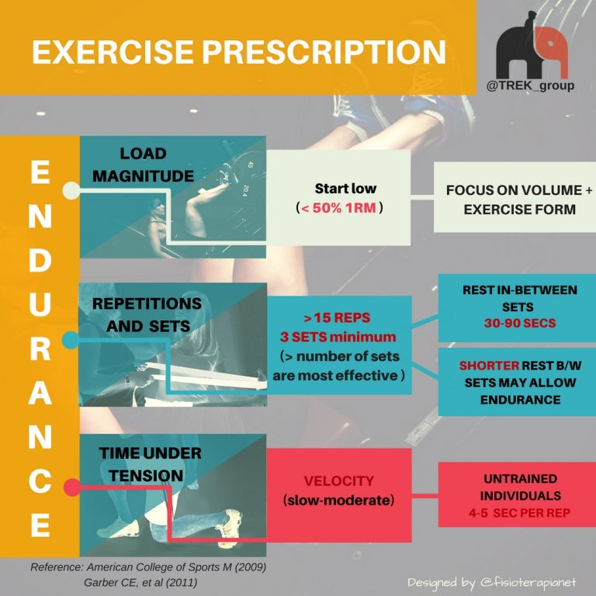 | 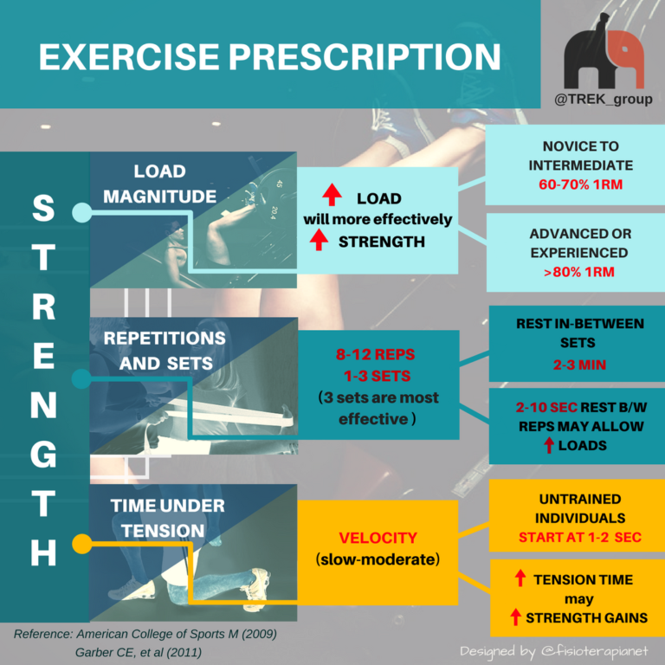 | 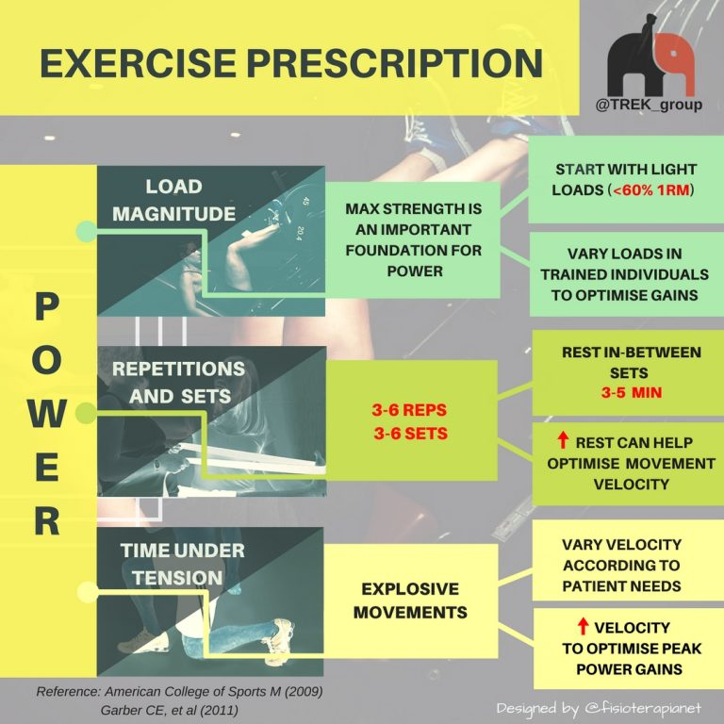

Pain during exercise
> 5 / 10
Progress exercise
Don’t change exercise
Discuss with your physiotherapist
< 2 / 10
2-5 / 10 (acceptable)

If you are able to complete your exercise program with minimal pain or discomfort try increasing the load, sets and/or reps
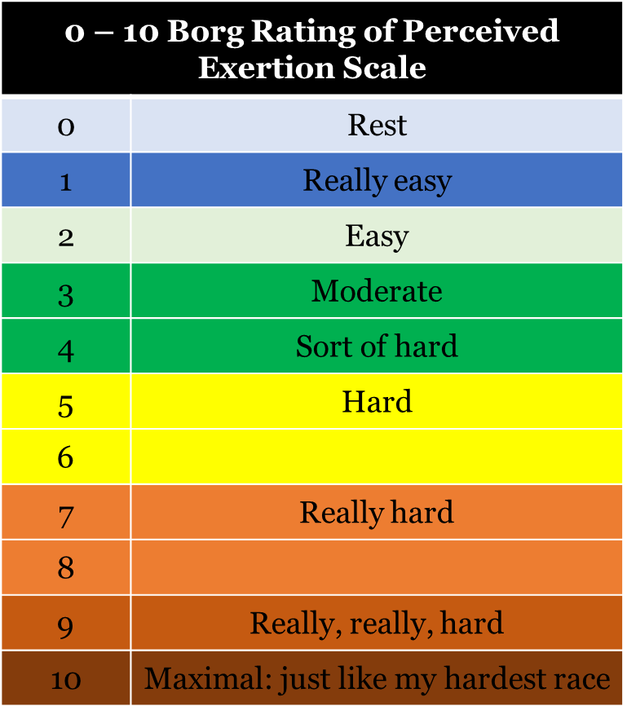 | - You can use this scale to measure your effort while you exercise.  - By measuring your effort and tracking it, you are able to progress your exercises to ensure you achieve the best outcomes.  - Try starting each exercise at a difficulty level you rate as ’hard’ (i.e. 5/10), and then increase in subsequent sessions.  - If an exercise does not allow you to keep your pain under 5/10 and settle within 24 hours (as described previously) reduce the difficulty level.  - Aim to increase level of difficulty to between 7 and 9/10 by increasing load (weight) or progressing to a new phase. Your physiotherapist will help guide though with progressions also.

Considerations when modifying exercise prescription

Exercise | Load/  progression | Reps | Sets | Rest b/w sets | Duration of rep | ROM | Therapeutic target
Your most commonly prescribed exercise?

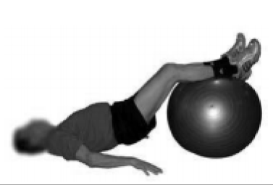 | Body weight/ longer lever, double to single leg | 10-15 | 3 | 30-60 seconds | 3-4 seconds | Hip flex/ext = 30/10 | Motor control, endurance (trunk, hip extension, knee flexion)
Hip extension strength?

Hip extension power?

Calf strength?

Case Scenario | Questions
- 78-year-old female  - Originally presented with bilateral OA knee pain, background of 2 falls in past 12 months.  - No other significant history, medications for elevated BP and cholesterol – managed and stable.  - Lives alone; more fearful of going out alone over the past 12 months since first fall.  - Does not drive; normally uses buses and trams but avoids this as concerned about falling.  - Completed GLA:D® exercise and education; knee pain no longer an issue. Fear of falling persists. | With the goal of addressing fear of falling:  - Using the exercises within the GLA:D® program, which exercises could you modify and how ?  - What lower limb strength/endurance/power exercises would you prescribe in addition to GLA:D® exercises?

Exercise | Load/  progression | Reps | Sets | Rest b/w sets | Duration of rep | ROM | Therapeutic target

